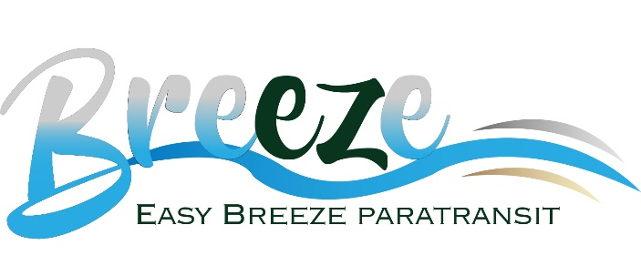
Rider’s Guide
Easy Breeze Paratransit is a door-to-door service complementing fixed route bus service provided on Hilton Head Island (Route 505) and in the city limits of Walterboro (Route 429). The service is available for persons with a temporary or permanent disability who meet the criteria established under the Americans with Disabilities Act. Passengers must be certified to use Easy Breeze Paratransit and applications can be downloaded here, or can be mailed by request by calling (843) 757-5782.

Service Area

Easy Breeze Paratransit serves areas within Hilton Head Island (Route 505) View Hilton Head Service Area and Hours here, and Walterboro Works (Route 429) View Walterboro Service Area and Hours here.

How to Apply

To determine eligibility, applicants are required to complete an application. Please note there are two parts of the Easy Breeze Paratransit application to be completed and submitted.

Download Part I (146 kb pdf) to be completed by the passenger and Part II (14.2 kb pdf) to be completed by the passenger’s physician or medical professional.

Please return applications via any of the following options:

- Email: latkinson@palmettobreezetransit.com
- Fax: Attention Easy Breeze Paratransit to 843-757-5788
- Mail: Easy Breeze Paratransit, 25 Benton Field Road, Bluffton, SC 29910

Easy Breeze Paratransit Eligibility After 21 Days

Staff will review applications promptly. While under review, applicants may schedule and use Easy Breeze Paratransit. Eligibility decisions will be made within 21 days of receipt of a complete application. For those applications not processed within 21 days of receipt, the applicant will be allowed to continue to use the service until such time as a written determination is made. Feel free to contact Easy Breeze Paratransit for assistance, by calling 843-757-5782, Option #3 or e-mailing latkinson@palmettobreezetransit.com

Scheduling a Trip

Once you are certified, you may begin using the Easy Breeze Paratransit service immediately. Please call 843-757-5782, Option #1, Monday through Friday between 6:30 a.m. and 5:00 p.m. to schedule your trip(s). Trips must be scheduled at least one day in advance, but not more than 14 days in advance. The cost for the service is $2.00 per one-way trip.

ADA Eligibility Card
Certified Easy Breeze Paratransit passengers will receive an ADA Eligibility Card with an ID number. This non-transferable card also allows the holder temporary eligibility on any ADA compliant paratransit system in the United States. Easy Breeze Paratransit reserves the right to require a new eligibility assessment at any time. A new eligibility assessment may be required for, but not limited to:
- Possibility of improvements in a passenger’s ability to use a Palmetto Breeze accessible low floor bus.
- Any improvements in public physical barriers previously preventing a passenger’s use of a Palmetto Breeze accessible low floor bus.
Visitors with Disabilities
Individuals traveling to the area, who present documentation of ADA Paratransit eligibility by a public entity, are eligible for Easy Breeze Paratransit services for any combination of 21 days during any 365-day period beginning with the visitor's first use of the service. If service is requested beyond this period, individuals will be required to apply for certification.
Personal Care Attendant and Companion
If a Personal Care Attendant is approved as part of the application process, that person will be required to travel with you (free of charge). You may request to have a companion travel will you. Please let the scheduler know at the time of your reservation. A companion is required to pay the normal fare of $2.00.
Travel Training
Travel training is designed to teach seniors and people with disabilities how to travel safely and independently on a fully accessible low floor fixed-route bus. Travel training determines how disabilities affect travel and then travel skills are tailored to each person’s needs. Remember, riding the bus does not jeopardize the ability to use Easy Breeze Paratransit services, but allows the passenger more flexibility and freedom to travel whenever they choose.
Benefits include:
- Learning to travel independently
- Greater self-esteem
- Flexibility of scheduling allowing freedom of movement within the service areas. For more information on Easy Breeze Paratransit, or any of the above information, please call 843-757-5782, Option #3 or email latkinson@palmettobreezetransit.com

This document and any of our brochures or service information documents are available in alternative formats, such as large print or audio, upon request. Please call 843-757-5782, Option #3 or email latkinson@palmettobreezetransit.com

